Work with Microsoft Thailand over your semester break.
Build on your experience’s and learnings from your University degree with a paid work experience program at Microsoft and discover what career paths at Microsoft excite you. We are looking for students who are looking to reach their full potential in a global IT company, joining us in our mission empower everyone on the planet to achieve more.
We offer a paid 8-12-week internship program, where you will be a part of a team working on meaningful, impactful projects and gain invaluable experiences, such as our signature Intern Learning Week. This is where all our interns from Asia Pacific come together for one week of learning and community building in Singapore.

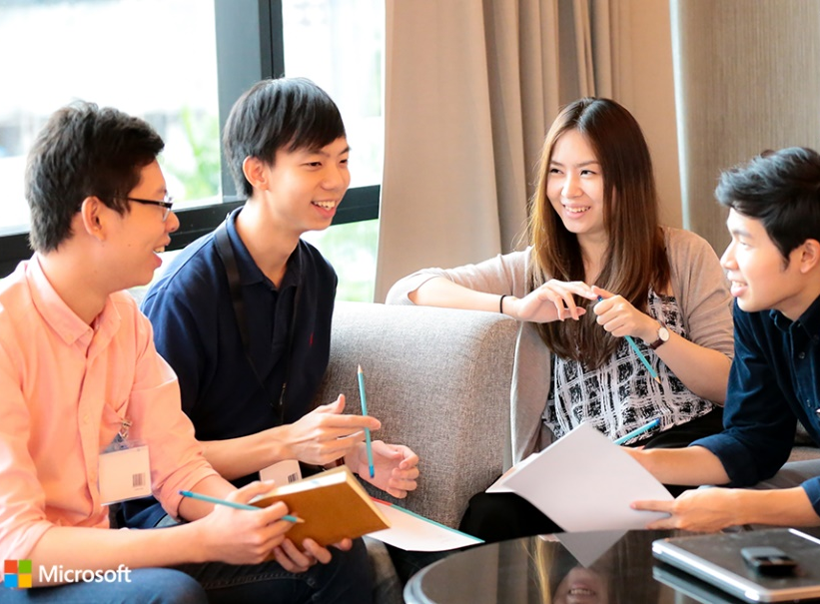
What you need to know
Our applications will open from the 2nd January 2017 until the 31st January 2017.

You must be available to work for 8-12 weeks from June-August/September 2017.

For MBA students to be eligible they must be on track to graduate from an MBA between June 2017 and June 2018 and have less than 7 years’ full-time work experience.
Learn more and apply here:
http://bit.ly/2hn81x6
For Masters (non-MBA) students to be eligible, they must be on track to graduate from a master degree in any major between June 2017 and June 2018 and have less than 2 years’ full-time work experience.

